Application security groupss :

You can use application security groups to configure network security as natural extension of an application’s structure, by arbitrarily grouping VMs and defining network security policies based on those groups. You can reuse your security policy and scale without manual maintenance of explicit IP addresses. The platform handles the complexity of explicit IP addresses and multiple rule sets, so you can focus on your business logic. (Instead of giving IP address hard coding multiple destinations, we can create ASG and can create inbound/outbound rule with ASG)

1. Create ASG

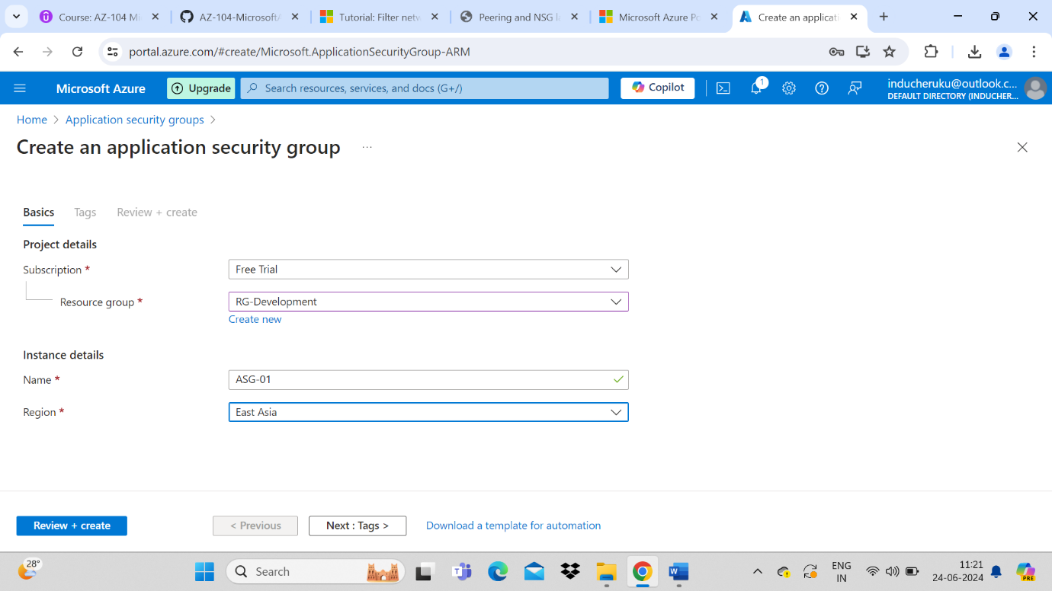

1. Now add and ASG to Virtual machine
2. Go to VM -> Click networking tab -> go application security groups -> Add ASG groups

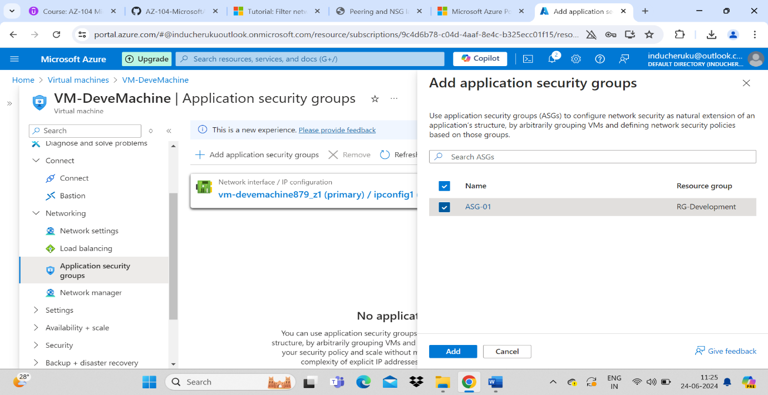

1. Now go to NSG and create a new inbound rule with ASG to allow traffic 80

